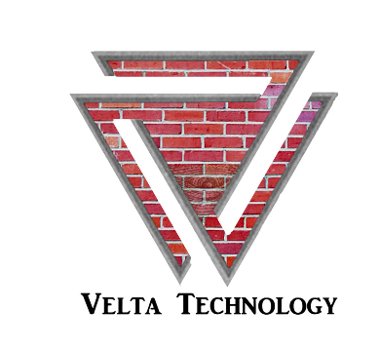

For Immediate Release Contact: Cody Sturgill
Phone: (314) 853-7679
Email: cody.sturgill@veltatech.com

Another Potential Worm Has Made Its Way
To The Surface

Cody Sturgill | Velta Technology LLC.

‘[St. Louis, MO - May 14th, 2019] Microsoft urged administrators of Windows 7, Windows XP, and Windows 2003 users to patch their systems "as soon as possible" in order to fix a serious flaw in those systems. Krebs on Security was quick to bring this to everyone’s attention in this article. The "wormable" flaw that the patches fix was compared to "WannaCry" by Microsoft officials.’ (Krebs on Security, Microsoft Patches)
Based on traffic patterns over the past year from hundreds of production ICS and SCADA networks, Velta Technology has found that over 50% of sites have unsupported Windows systems such as Windows XP. This is because computers in Industrial Control Systems (ICS) are difficult to upgrade. If you are unable to upgrade, consider an offsetting control such as micro network segmentation along with continuous vulnerability monitoring.
Simon Pope, director of incident response for the Microsoft Security Response Center, said, “This vulnerability is pre-authentication and requires no user interaction. In other words, the vulnerability is ‘wormable,’ meaning that any future malware that exploits this vulnerability could propagate from vulnerable computer to vulnerable computer in a similar way as the WannaCry malware spread across the globe in 2017.” The operation systems that are at risk of this “wormable” vulnerability are: Windows 7, Windows Server 2008 R2, Windows Server 2008, Windows 2003, and Windows XP. Windows 8 and 10 are not affected by this problem.

The Vulnerability works by using a Remote Code Execution pre-authentication state of Windows Remote Desktop Protocol. This Protocol is generally used in the OT (operational technology) environments when giving user access to ICS (industrial control systems). The problem effects the segmentation between external and internal networks.
For more information on micro network segmentation, asset discovery, and continuous vulnerability monitoring for your ICS or OT network, please contact Velta Technology. Velta Technology, along with our partner Claroty, specialize in the OT environment. We will assist you with the tools and resources necessary to ensure you have visibility into your OT network, and you are prepared to act on this “critically severe” vulnerability.

For more information on this particular threat, please reference CVE-2019-0708.

